MARKING COMPLETED

MARKING COMPLETED
- The goal is to add a "Mark Completed" button and "Tasks Completed" counter at the bottom of the window
- We will need to define functions and update our json file to keep track of the running total of completed tasks

COUNTER LABEL
- We will use a global variable to keep track of all our completed tasks
- In order to have a "Tasks Completed" counter at the bottom of the window, we will use a label widget
- However, we will need to update this label widget everytime we complete a task, and we will use .config( ) to do this
- We'll give this label 10 pixels of vertical padding

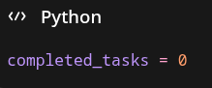

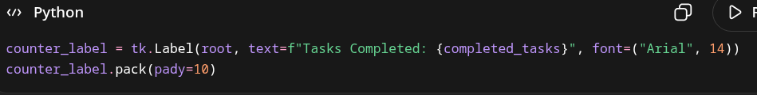

UPDATING COUNTER LABEL
- We'll define a function update_counter
- We'll use .config( ) on our label widget to update the text paramter to include the updated completed count

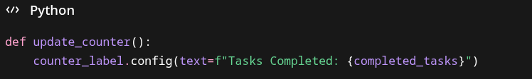

MARK COMPLETED FUNCTION
- This function will delete the task from the listbox widget and update the completed_tasks counter
- We'll call the global completed_tasks variable
- Save the user's selected task
- Stop the function if nothing is selected
- Grab the index of the selected task
- Delete that index from the listbox widget
- Delete that index from the global tasks variable
- Add 1 to the global completed_tasks counter
- Save tasks
- Call the update_counter( ) function

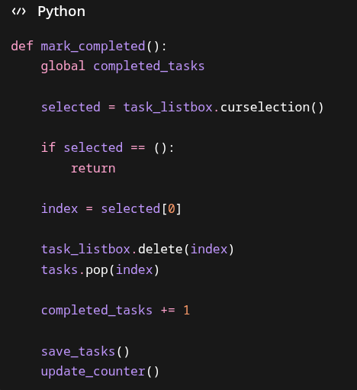

MARK COMPLETED BUTTON
- We'll create a "Mark Completed" button and put it in the same frame as our other buttons and pack it to the left as usual
- We'll pass the command=mark_completed parameter

UPDATING THE SAVE FUNCTION
- We're going to save the running total for completed tasks within our tasks.json file so that even when the user closes the program, they can see how many tasks they've completed in their lifetime
- However, we're going to have to change the layout of the json file, which will also force us to change how we load the json file
- When we save data to our json file, we'll have 2 dictionary keys:
  - "completed tasks"
  - "tasks"

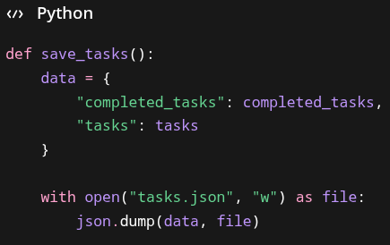

UPDATING THE LOAD FILE
- Because we're updating our global variables, we'll need to call our global variables within our function
- We'll use a try-except block when opening the json file in case this is the first time running the program as the json file won't exist yet
- We'll load the json file as normal, saving the json data to a local variable data
- We'll update our global variables by calling on the keys of the json dictionaries
- Because our tasks are loaded in json as a dictionary, with "tasks" as the key with a list of dictionaries as the value, we'll use a for-loop to insert each task description by calling task["description"]

